EXECUTIVE SUMMARY

**On**

**Nigeria’s Covid-19 data and the effect on the Economy.**

COVID-19 is not only a global pandemic and public health crisis; it has also severely affected the global economy and financial markets. Significant reductions in income, a rise in unemployment, and disruptions in the transportation, service, and manufacturing industries are among the consequences of the disease mitigation measures that have been implemented in many countries. It has become clear that most governments in the world underestimated the risks of rapid COVID-19 spread and were mostly reactive in their crisis response. As disease outbreaks are not likely to disappear in the near future, proactive actions are required to not only save lives but also protect economic prosperity.

This summary gives insights on the Nigeria COVID-19 dataset.

**Data Overview.**

1. Nigeria Centre for Disease Control data set for each state in Nigeria and it contains:

* No. Of cases (Laboratory Confirmed)
* No. of cases (On Admission)
* No. discharged
* No. Of Deaths
* States Affected

1. The Johns Hopkins University Center for Systems Science and Engineering (JHU CSSE) daily data on confirmed, death and recovered cases across different countries.
2. Nigeria Community Vulnerability Index data
3. Gross Domestic Product Data for Nigeria.
4. State Budget Data.

**Analysis.**

1. A peek into the budget data showed reductions across all states as a result of the pandemic.

|  | **states** | **Initial budget (Bn)** | **Revised budget (Bn)** | **difference** | **percent** |
| --- | --- | --- | --- | --- | --- |
| **0** | Abia | 136.60 | 102.70 | 33.90 | 24.82 |
| **1** | Adamawa | 183.30 | 139.31 | 43.99 | 24.00 |
| **2** | Akwa-Ibom | 597.73 | 366.00 | 231.73 | 38.77 |
| **3** | Anambra | 137.10 | 112.80 | 24.30 | 17.72 |
| **4** | Bauchi | 167.20 | 128.00 | 39.20 | 23.44 |

1. Lagos state has the highest number of Lab confirmed, Recovered and Death Cases in Nigeria.

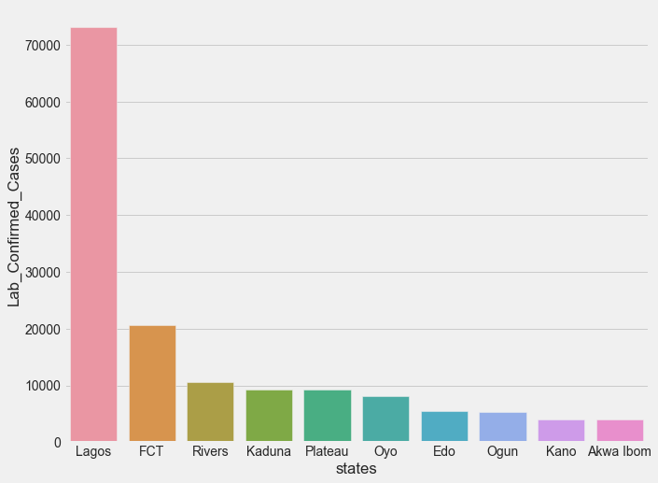

1. The was a significant drop in the GDP for the second and third quarter of 2020 comparedto 2019 as seen from the visualization below.

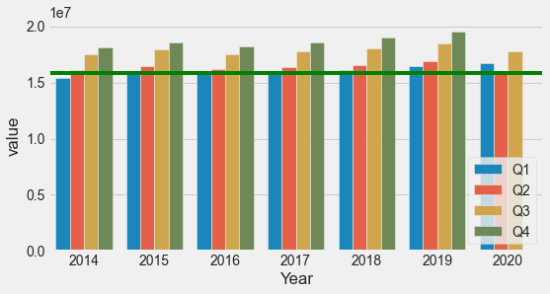

1. Correlation between features of the Nigeria Community Vulnerability Index data and the ncdc dataset.

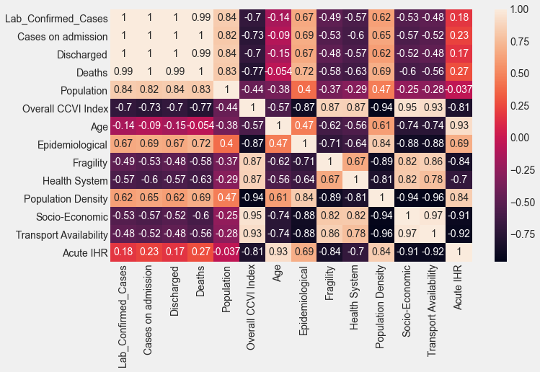

**Conclusion.**

* Lagos has the highest number of confirmed and recovered and death cases in nigeria.
* The Confirmed, Recovered and Death cases are directly proportional.
* The higher the population density the higher the cases.
* High correlation between Confirmed cases, Deaths, Discharged.
* Budget data shows that budget was drastically reduced as a result of the pandemic.
* GDP for the second quarter of 2020 reduced compared to previous years.

References.

* + https://www.frontiersin.org/articles/10.3389/fpubh.2020.00241/full